#basic ggplot
library(ggplot2)
bp <- ggplot(metadata, aes(x=Location, y=cort.10, group=Location)) +
geom_boxplot(aes(fill=Location))
bp
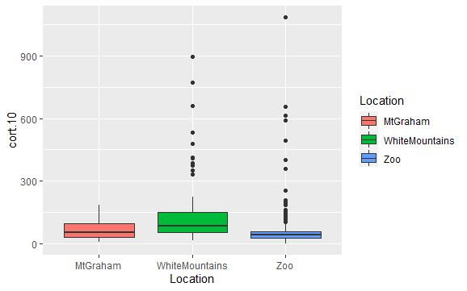
# Split in vertical direction by season
bp + facet_grid(Season ~ .)

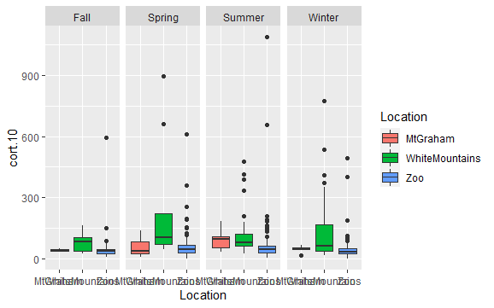
# Split in horizontal direction
bp + facet_grid(. ~ Season)
